W.R.A.H. Main Page
(Write and Read at Home)
Directions: Read for at least fifteen minutes on Monday, Tuesday, Wednesday and Thursday. When you finish reading, complete one of the boxes below. By Friday, you should have completed any four boxes.
Fiction Book Choices
A  Compare and Contrast yourself to a character in the book. Create a Venn Diagram. 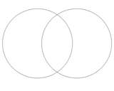 | B  Create a list of the important events or information you encounter in the book. 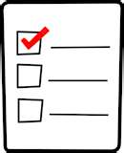 | C  “Popping Predictions”  Before you begin reading, skim the chapter you are about to read and write down a prediction.
D  What Happened?  Write a 3-5 sentence summary of what you read. Make sure you use correct spelling and punctuation. 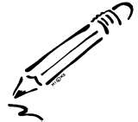 | E  Write 3-5 sentences stating what you think is the author’s purpose for writing the story. What does the author want you to know? Why is he/she writing this story?  - To inform  - To persuade  - To entertain  - To show emotion | F  State the problem of the story in 2-3 sentences. Use correct punctuation and spelling!  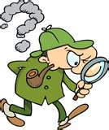
G  Write three connections to what you read.  - Text to text  - Text to self  - Text to world | H  Pretend you are the teacher! Create three questions you would ask your students about your story! 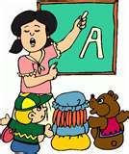 | I  Draw an illustration of an image you created in your mind as you were reading the story. Be sure to include a caption.  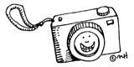

W.R.A.H.
Write and Read at Home
Nonfiction Book Choices
A1  Create a KWL Chart before and after you read you book.  K What I already know W What I want to learn L What I learned | A2  List 3 facts from your book. List two opinions that you have about the topic.  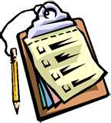 | A3  Give a Recommendation!  Answer these questions in complete sentences. Who is the author of your book? Why do you think the author wrote this book? Who would want to read this book?
A4  Think About and Write…  Most Interesting Fact Most Surprising Fact Most important fact | A5  Write 3-5 questions you would ask the author if you had the chance to meet him/her. 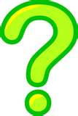 | A6  Create an Acrostic Summary on the topic of your book.  Example:  Bats come in different colors  All bats are mammals  They eat insects and fruit  Some people are afraid of bats
A7  Write three connections to what you read:  - Text to text  - Text to self  - Text to world | A8  Pretend you are a teacher! Write five new vocabulary words you learned. Next to each word, write what it means. | A9  What is the main idea of what you read? Explain the main idea in your own words with at least 3-5 sentences.  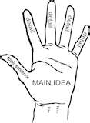

Name: _______________________________________________ Due: Friday

W.R.A.H
(Write and Read At Home)
Monday
# of minutes read: ________ OPTION:_______________________
Title of Book: _________________________________________ by: ___________________________________

Tuesday
# of minutes read: ________ OPTION:____________________
Title of Book: _________________________________________ by: _____________________________________

Wednesday
# of minutes read: ________ OPTION: _________________
Title of Book: _________________________________________ by: ___________________________________

Thursday
# of minutes read: ________ OPTION:_________________
Title of Book: _________________________________________ by: _________________________________________

REMEMBER TO HAVE PARENT SIGN BELOW!
Adult Signature: ___________________________________________________________
I confirm that my child read at least fifteen minutes each day and completed the reading responses on his/her own OR with appropriate assistance based upon my child’s needs.

