RESPECT
Number and Age of Students: 25 students, K-7
Purpose: Redefine and fortify the guidelines and expectations of the New Directions Program to provide a safe and happy environment conducive to the social-emotional well-being of all students and coaches involved.
Objectives:
Students and Coaches will be able to identify what the word Respect means through discussion.
Students and Coaches will be able to show what respect looks like through role-playing respect scenarios.
Students and Coaches will be able to agree to show respect to others and stand up for the respect ideals that we have agreed upon.
Materials:
- RESPECT Poster
- Big Paper
- Markers
- Lists of Each Color Group
- Print Outs of Scenarios
- Poster with “How to Work in Groups” Guidelines
Anticipatory Set:
- Discussion about Respect
“We have all been struggling with the rules and expectations of our program in the past few weeks. It would be unfair to say that it is anyone’s fault entirely, but it is up to all of us together to work to find a solution. Coaches and student, equally, we need to work together to define what we expect from each other when we are here for New Directions.”
“There is one word we are going to focus on today, and here it is.” Pull out and pin up “RESPECT” Poster.
“What do you think respect means?” Teacher scribes definitions/words/ideas onto Big Paper.
- Try to be conscious of calling on students who DO NOT have their hands up for this section
Procedures: Role Playing
- Grouping
  - “Now that we all have some ideas about RESPECT, we are going to do an activity to explore what respect looks like.”
  - Set up these Groups:
BLUE | GREEN | RED | YELLOW | ORANGE
  - How to work in Groups:
    - Every person must have a job or role
    - Every person must contribute (or give) an idea
    - Every person must know how each scenario relates to RESPECT
    - Older students job is to be a leader – help younger students, read the prompt, direct people’s thought to accomplish a goal
    - Younger students job is to listen and contribute – listen to what the older students ask from you, give your ideas, and be a part that makes the group better
    - Coaches act as facilitators – direct the group when they get stumped, answer questions, guide discussion in a positive direction, remind the groups of our purpose (RESPECT)
- Role Playing “Show RESPECT”
  - Each group will get a role play scenario
  - Everyone must follow the Guidelines for How to Work in Groups
  - Groups have 5-7min to read their scenario and come up with a 15-30 second play or “Skit” to demonstrate how they can “Show Respect”
  - After each group shows their skit, they can explain how they tried to “Show Respect”
    - Can involve discussion from whole group
  - Guided Questions: if the students are having a hard time explaining how they “Show Respect”, the teacher can ask,
    - “How did the student feel whose books were thrown on the ground?”
    - “Was it hard to stand up to your group member and say they were not doing their job?”
    - “What does it feel like to be on a team? What does it feel like to be on a team that doesn’t work together?”
Closure:
- Redefine Respect
  - Go back to the list we started with on RESPECT
  - “Now that we have seen RESPECT in action, lets come back and write down some of the things we have seen.
What does RESPECT look like?
How do we RESPECT other people?
How do we RESPECT the rules and expectations?
How do we RESPECT property or people’s things?”
- “This is exactly what we will all expect from each other from now on. Now, if someone is not being respectful, what are we going to do?”
Possible Answers:
  - Be honest with them, say “You are not respecting me in this way and I do not appreciate it.”
  - Explain to that person how they are not respecting you, ask them to change that.
  - If you cannot solve the problem yourself, ask your Coach for help.
  - If you and your coach cannot solve the problem, ask Miss Ashley to help.
- “We will be discussing RESPECT again soon, and we are going to be making some changes so that we can all get and give the RESPECT we deserve. That is all the time we have for today, so before you leave, everyone is going to turn to a partner. Look that person in the eye, shake their hand, and say “Thank You, I RESPECT the teamwork or hard work you showed today.”
- “We will be posting our RESPECT agreements up and making an agreement sheet for everyone to sign tomorrow.”
Follow Through:
- Post our RESPECT agreements clearly for everyone to see
- Write RESPECT agreements out, and have each student sign them.
- Next Initiative: Show Your Respect, with Random RESPECT
  - Each week, all students will be respected to show a Random Act of RESPECT to someone at New Directions.
  - This will begin with the following Group Activity:
Group Activity – Round Robin Compliments
“One way to show your respect for someone is by complimenting them. We want every person to feel like they are appreciated, so we are going to try Round Robin Compliments.”
- Each student starts with a heart shaped paper with their name in the middle in bold.
- All of the students sit in a circle in chairs.
- We will be passing the papers around and students write one nice thing, “a compliment”, on that person’s paper until they made it back to their owner.
- Everyone takes a moment to read their compliments.
- Everyone goes around the circle and shares one compliment they received.
Scenario Legend:
The purpose for each scenario can be defined as:
Scenario 1: Respect for Rules or Expectations
- Students will be able to demonstrate respect for rules and expectations by exploring what might happen in this group work scenario.
Scenario 2: Respect for People
- Students will be able to demonstrate respect for people by exploring what might happen in this teamwork scenario.
Scenario 3: Respect for Property & People
- Students will be able to demonstrate respect for property and people by exploring what might happen in this friends and foes interaction scenario.
Reflection:
- Flexible with groups – some students absent so we had 4 groups
- Coaches did very well as facilitators. Kept the student on task as much as possible.
- Older students did well as leaders. Most were willing to help guide the group.
- Younger students did ok as listeners. Many of the younger kids were running around having a hard time cooperating during small groups. During discussion, younger kids were first to have their hands raised.
- Presentations of skits were scattered but got the point across.
- First discussion of Respect was very “face-value”, we heard your typical responses. After skits, the second group discussion of Respect we had more in depth answers that were benefited by the demonstration and discussion of “What is Respect, What does Respect look like, What does Respect Sound like?”
Appendix:
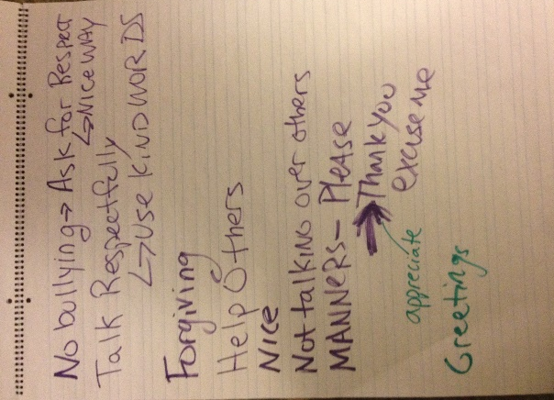
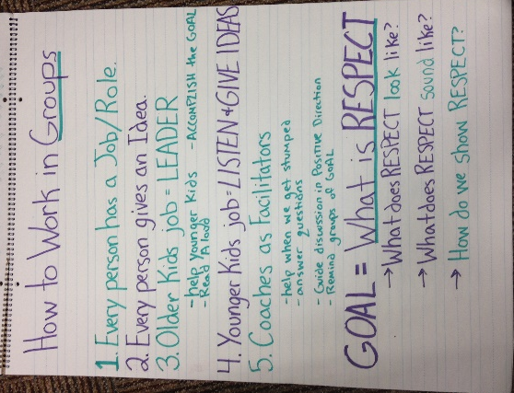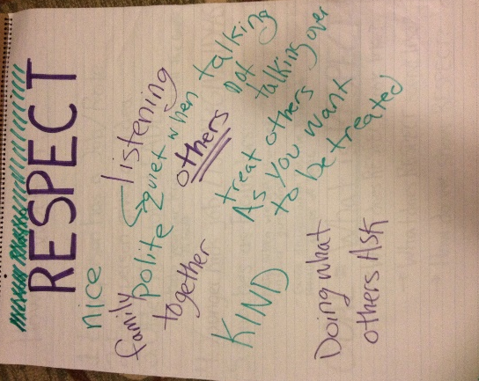

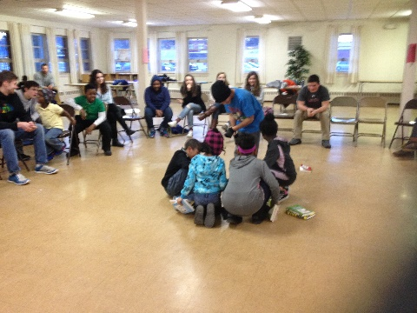
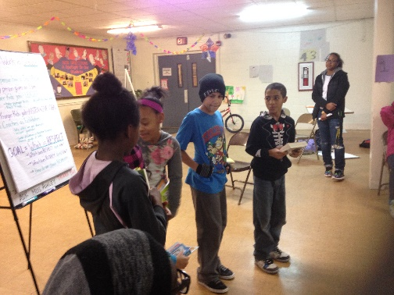
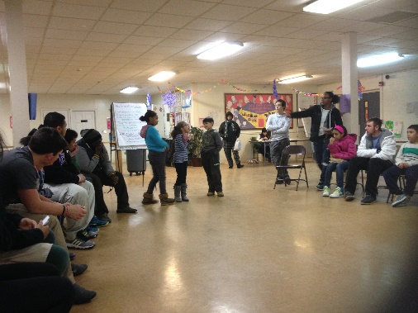
Groupwork Guidelines Discussion 1 Discussion 2

SCENERIOS
Scenario 1: You are with a group of friends in a classroom working on a project, creating a poster. Everyone in the group needs to do one part to make the poster complete. You work on the poster for one week, and at the end of the week, one group member does not have their part complete.
What does each group member in the group do? Who questions the group member who didn’t complete their part? What do they say?
Roles: Everyone Must Play a Part
- 4 group member who complete project
- 1 group member who does not complete the project

Scenario 2: You are on a sports team together. You have a big game at the end of the week. At practice one member is goofing off and tripping the teammates on the field.
What does each teammate do? Who points out the teammate tripping people? What do they say?
Roles: Everyone Must Play a Part
- 4 teammates
- 1 teammate who is tripping people

Scenario 3: You are at school in the hallway going to your next class. As you walk down the hallway with your friends, someone shoves the books out of another person’s hands, and begins to make fun of them.
What do you do? What does the person who shoved do? What does the person who lost their books do? What do they say?
Roles: Everyone Must Play a Part
- 3-4 friends walking down the hallway
- 1 Person who shoves the books from someone’s hands
- 1 Person who is carrying the books

