World Read Aloud Day:
Mind Your Monsters

- Lesson Plan Details
Day/Date: February 24, 2016
Grade Level: K-5
Duration: 1 hour
Unit-Subject: ELA/Social-Emotional

1.1 Integration of Learning Outcomes/Objectives
SWBAT use words that show respect such as Please and Thank You with peers and adults.
SWBAT recognize a time in their lives when they have difficulties accomplishing a task due to “monstrous” behavior.
SWBAT communicate about this “monstrous” through an art and writing activity.

1.2 Standards
*No PA Core standards will be used for this lesson, although we will note the sections of the New Directions Mission Statement which this lesson correlates to.
- To assist students in developing socialization and coping skills and in developing a positive self-image.

1.8 Materials/Equipment
- Mind Your Monsters by Catherine Bailey and Illustrated by Oriol Vidal
- Art Supplies – ex: paper, markers, scissors, glue
- Word Bubbles for Monsters (# of students)
- Ready-made Monster for example
- “Please” word prompt for wall display

1.3 Anticipatory Set
I am here today to read to you because we are celebrating an international holiday. Today is World Read Aloud Day! Scholastic, a company that writes and publishes books, started World Read Aloud Day to help people realize how important reading books aloud can be.
Today, we are going to read a beautiful book that I really enjoy. You’re going to need to have sharp eyes and listening ears on because there is a lot going on in these illustrations and there are some very important key words we are looking for today.
- Intro Book
  - This book is about monsters, and before we read I want you to think about your own monsters. Some of us have monsters that make things difficult when we go to bed, some of us have monsters when we don’t get something we want. Just have that thought in your mind as we go through out book.

1.4 Procedures
- Read Aloud – stop to ask questions or not important words
  - Important “Magic” Words: Please
  - Look at how the author and illustrator worked together to make certain words look different. Why do you think they did that? What does it make you think about those words?
- Discussion about our Monsters
  - This town had some really terrible monsters, but they weren’t that hard to live with once they knew how to work with them. If you think about it, every person has their own monsters too. I can tell you that I have a hungry monster. When I am hungry, my monster comes out and makes me angry and grumpy. Some of us have monsters that come out when its time to do homework. Everyone has a monster.
  - Ask the kids what their monsters are?

1.5 Closure
- Art Activity: Make your Monster
  - Now that we know our own monsters, we are going to make them come alive. Here is my hungry monster. We are going to take some time to create our monsters. Everyone’s monster can look, remember that each of our monsters are unique.
  - Once you’ve made your monster, here is the important part… Take a look at my word bubble I’ve attached to my monster. What do you think that is for? What was the important Magic word we read about? *ASK FOR RESPONSES* Exactly, Please! The word bubble is to ask our monster to Please stop making us do those terrible things. I am asking my monster: Please stop making me mad and grumpy when I’m hungry. Maybe you can ask your monster: Please don’t make my head hurt when I’m doing homework.
*Take Pics of kids with their monsters at the end

1.6 Differentiation
Because this is being done with a large range of ages and ability levels, differentiation will be geared toward ability level and age.
K-1 These children will be required to work with an academic coach to accomplish the art craft and receive assistance writing in their word bubbles.
2-3 These children will have the skills to create their own artwork, but may need coaches assistance to utilize the important “magic” word Please in their word bubble statement.
4-5 These students should be independent enough to create and write effectively on their own for this project.

1.7 Formative/Summative Assessment of Students (P-12)
Formative: Because this lesson is fairly informal and for an after school program, the formative assessment will be based around students ability to participate in discussion, have appropriate behaviors while listening, and relate to their own behavior in order to create their monster. This will all be done in an observational assessment of understanding.
Summative: There will be no summative assessment for this lesson.

1.9 Technology
*No Technology will be used in this lesson

2.1 Reflection on Planning
- The goal of this lesson is not only to read aloud a fun and engaging book, but get the students to think about themselves and their own behavior. In the program, our students lack skills in self efficacy, assurance, and recognition.
- The book I chose takes a simple concept of respect, like saying please, and creates a fun story to go along with it. The students in the program need a great deal of reinforcement with concepts of respect. This book makes it very clear how to use the word please and the discussion we will create is reinforced by the monster theme.
- The art activity allows students to recognize one of their undesirable behaviors and bring it to life. We will create a wall display with our monsters so the students can see them and reference to their own behavior.
- The concept of saying please to your monster reinforces a simple concept of respect, but also helps these student begin to acknowledge their own behaviors. This in turn will hopefully spark a moment of self-recognition and self-efficacy in our students.

2.2 Reflection on Teaching

2.3 Appendix
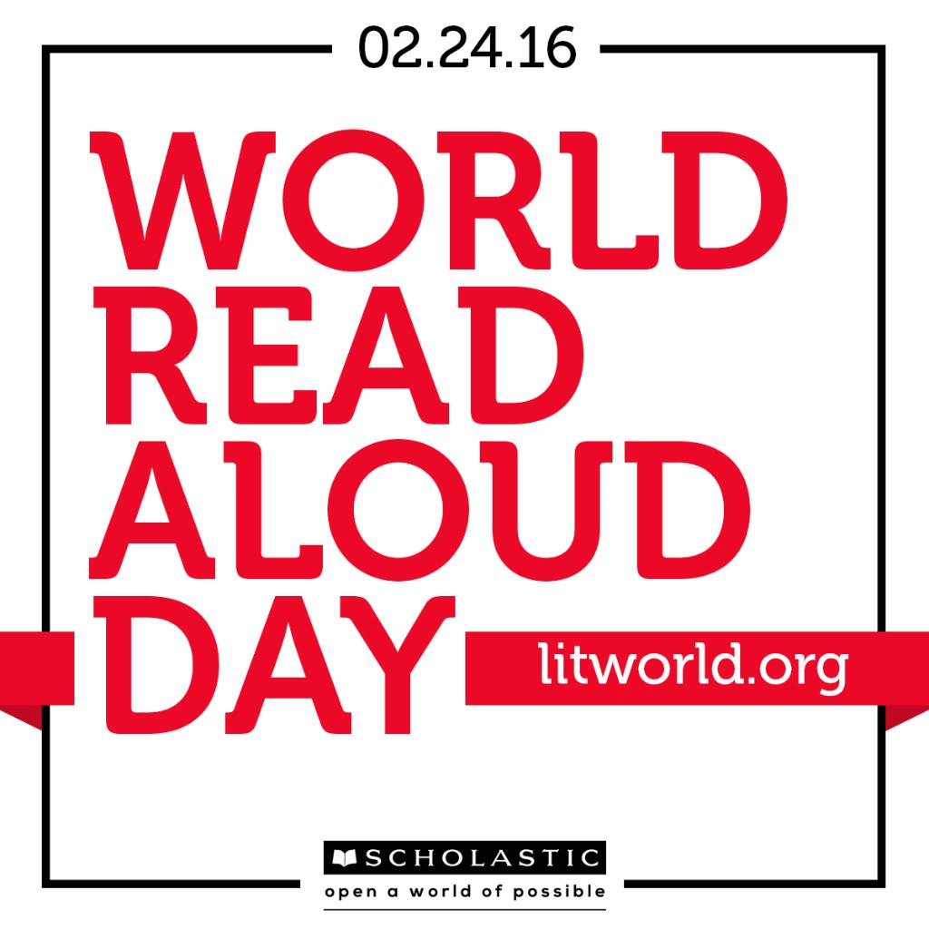

Please

What’s the Magic Word?

