2 – even numbers
3 – add all the digits – they will equal 3, 6 or 9
3x7=21 (2+1=3), 3x42=
4 – the multiple of 2 twice or Double the number twice
4x3=12 same as (2x3=6) doubled = 12
4x3 = 3x2=6x2=12
5 – ends in 0 or 5
6 – they both end in the same digit
6×2=12, 6×4=24, 6×6=36
8 – multiply the number by 2 three times
8x3= (3x2x2x2)=24
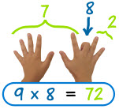
9 digits add up to 9
9x8=72 (7+2=9)

10 – ends in 0
11 – the number repeated – up to 9
9x11=99, 2x11=22, 5x11=55

